

Mohd. Razia Alangir Banu
D. VENKAT SAI
2520090034
CSIT
CO-2

Case Study: Meesho – Warehouse & Sales Analytics Management System
Meesho manages a large warehouse system containing product inventory, order details, and daily sales records.
To efficiently process this large-scale data, B-Tree/B+ Tree concepts are used for indexing and fast retrieval of records. Segment Tree is implemented for performing range-based queries such as calculating total sales or maximum orders within a specific time range. Fenwick Tree is used for prefix sum operations to analyze cumulative sales data. These data structures help Meesho improve analytics, inventory tracking, and warehouse management efficiency with optimized O(log n) operations.

Implementation Details
1. Warehouse product and sales data are organized using tree-based indexing structures.
2. B-Tree/B+ Tree concepts are used for efficient storage and retrieval of large product datasets.
3. Segment Tree is implemented for range queries such as total sales and stock analysis.
4. Fenwick Tree is used for cumulative sales and prefix sum calculations.
5. Updates to stock and sales records are handled efficiently using logarithmic-time operations.
6. The system ensures optimized warehouse analytics and scalable data processing performance.
Output:

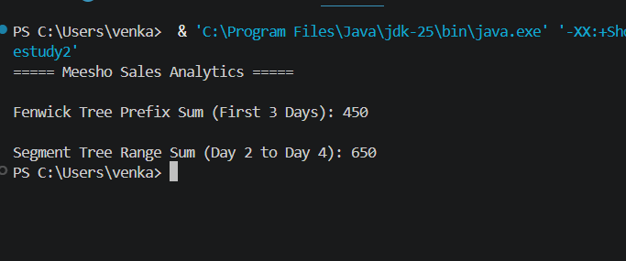

The Meesho warehouse management system effectively uses B+ Trees, Segment Trees, and Fenwick Trees for fast data retrieval and analytical processing. These structures improve scalability, sales tracking, and warehouse efficiency while maintaining O(log n) complexity for updates and queries.

Github link: https://github.com/Venkat-267-byte/DSA-II

